Carina Cricket Club 2023/2024 - Fielding, Warm Up and General Field Based Cricket Activities


Contents

- Warmups benefits (game days and training)
- Warm up activities
- Fielding Basics
- Fielding Drills.
- Running Between the Wickets Basics
- Running Between the Wickets Drills
- Cricket Skills Games/Activities

This season at Carina we are promoting a training program that is more field based. Reason being the game of cricket is played on a field and therefore we would like to have our training replicate that where we can as there are certain skills that are certain skills that are hard to learn in the confines of the nets. Carina has a lease for Bedivere Street Park every weekday afternoon. If coaches would like to take a session there, please contact Coaching Director Millan Agarwal via 0404692504.

Warmups
Benefits of warmups:
- Warming up increases your heart rate and therefore your blood flow. Enabling more oxygen to reach your muscles. A warm-up also activates and primes the connections between your nerve and muscles, which improves the efficiency of movement.
- Improves performance at training and games.
- Reduces changes of injuries.

How to warm up?
- ALWAYS begin with a dynamic warm up as it’s best to do a movement based warm up before activity, aim for about 30 metres of distance covered for each of these; high knees, but flicks, side skips, soldier walks, floor sweeps, walking lunges, squats (few steps in between), 50% runs, 75% runs, 100% runs.

High knees –
https://youtube.com/shorts/TV4pp_aIDMY?si=gw_AQWSmZ1wjk5Nm
But flicks –
https://youtube.com/shorts/u2cg9fcQphs?si=6jNn15qhPE3081SQ
Side skips –
https://youtu.be/HU13xangCEk?si=bRCxIDEMEsVr_sIO
Soldier walks –
https://youtu.be/ksNl4zEynMo?si=QCcg0QXVRg8Xb7Gr
Floor sweeps –
https://youtu.be/jG1DPrIsDn4?si=U8ZaK01hVBNzdrPW
Lunges –
https://youtu.be/DhPDsFdcgxU?si=3nDnDRKvN_OrU88i
Squats –
https://youtube.com/shorts/AIZ8q1qruKw?si=ATQH09FlQ62DWBn7

- This can be followed by some stretching (legs, back and arms).
Brett Lee –
https://youtu.be/16Ib_EdKzvM?si=nm7dz8gK479LVhXa
Lower body –
https://youtu.be/zQa9QAkuHxU?si=_BWgaukg8S0122QT
Back –
https://youtu.be/2eA2Koq6pTI?si=S5zZgbl7ISGRprrr
Arms –
https://youtu.be/BkLFyubXaFQ?si=Y5vBaHnxe9XT7g67

- IMPORTANT – one thing Carina is looking to highly encourage is throwing as part of the warmup for all fielding sessions. Reason being that a lot of players don’t throw much at training and then have to preform 3-4 big throws sporadically during a game, which puts a lot of stress on their shoulder, by having a strong throwing load, your body is conditioned to throw at high intensity and of course your team will be a better fielding team as throwing is such a regular part of fielding.

- Structuring a throwing warm up. Start with 15 throws each from five metres away, wrist flicks to practise the wrist release (start by holding the wrist, followed by holding the elbow, this helps isolate key areas). Another 15 throws from 15 metres away, feet side on but still and isolate the upper body, front arm reach, and pull in, throwing with a high release. 25-30 throws at high intensity (can step into the throw now and follow through) from 25-30 metres away (can be closer for younger ages) either throwing at a partner (on the bounce or they may have a catching glove), or at a cone 25-30 metres away from each thrower. As a final progression, can go even further away and do some throws. Ensure whilst the throwing warm up is occurring that the coach is walking around and giving some tips on throwing technique, and please also ensure that throwers always have a clear target to aim at.

*Please feel free to make use of the catching mits we have at the club. Alternatively, can use bounce throws or as I said have a target to aim at in between the partners, so the partner can just field the throw rather than catch it (ensure the partner uses the long barrier).

Great throwing program (helps explain the above) –
https://youtu.be/aL7oJvYfmjU?si=oUvxwBg1oNv-MURy
Throwing drills –https://youtu.be/ZJyecskN2Fs?si=kYjdQ_TxbBvbMUVK

Fielding Coaching Guide

Catching
- Feet move laterally.
- Hands work together as one. Fingers pointing down or pointing up based on height.
- Hands go out in front to catch the ball (just in front of eyes) and then bring it into us (soft hands).
- Watch the ball all the way into our hands.
https://youtu.be/lX0zAzcZs4c?si=icOryr4vwAUV1Rvr
High catching
- Stay still and work out where the ball is going to land.
- Move to where the ball is and set yourself under the ball. But still be prepared to move slightly if needed.
- Catching up above the shoulders and bringing the ball into us (soft hands). Same hands technique as normal catching.
- Running forwards to the ball = fingers down when catching. Running backwards to the ball = fingers up when catching. Stationary under the ball = can choose fingers up or fingers down.
- Watch the ball all the way into our hands.
https://youtu.be/xZ3qsXGQbjM?si=Bt4KPYLhxV2Gtv7b

Ground fielding
Attacking; run towards the ball as fast you can (attack), get side on, bend the knees, watch the ball into our hands. https://youtu.be/q4MEpushiDs?si=2nhk-oZKYoxmyQU9
Defending; align yourself with the ball, drop a knee and form the long barrier position, running to the left = drop the left knee, running to the right = drop the right knee. Have your knee and heel together to ensure there is no gap. Hands in front of body.
When attacking the purpose is to secure the ball as fast as you can to affect a run out.
When defending, the purpose is to stop the ball from going past you.

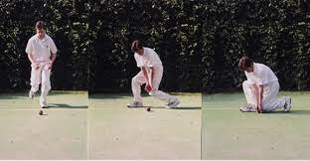

Throwing
Hold the ball cross seam to avoid the ball swinging, we want our throws to not swing so that they are easier to control, feet to the target, side on point towards the target, throwing arm extended back, pull front arm in when throwing the ball with high release, follow through down past opposite knee, take steps towards your target as a follow through, drive back leg towards the target.
When underarm throwing, key is to step forward to the target with your opposite leg and keep your arm straight.
HIGHLY RECOMMEND doing regular throwing as part of your training program. Doing big throws in the games without any regular throwing practise puts a lot of pressure on your arm.
https://youtu.be/IrXJ-6so8AU?si=sfYnbLB54DOvtFDY
Backing up
Align yourself with the angle of the throw, give yourself enough depth to ensure there is space to move either side, execute defensive ground fielding.

Fielding Drills

Attacking ground fielding races – Have two single file lines with the two people at the front racing to see who can get the ball in the quickest to the keeper. Promote attacking the ball and quick release. Can do with over arm or underarm throws. Can include points (first line to have five wins for example). The two people who just people go to the back and wait their turn.

Three stations fielding drill – Coach hits a catch out, the catcher underarms the ball at a stump, the fielder on the other side backs up by attacking the ball, replacing the feet and throwing at the far stump for a direct hit, where a fielder behind the stump backs up (defensive ground fielding) and throws it to the keeper who hands it to the coach and you repeat the process. Can add points and time it to lift intensity. Run to the station you have just thrown to stay moving.

Two lines drills – Have two single file lines with the two people at the front communicating to determine who will catch the hight catch or field the ground ball. They then pass the ball to the other person who throws it back. Can include elimination where if a fielder misses the ball or drops the catch they are out, but if someone in their catches or fields the ball successfully they can come back in, first team to lose all their players loses. The two people who just people go to the back and wait their turn.

Perfect plays – Have fielders take their place in the field coach hits the ball out and they have to attempt a direct hit run out followed by a throw to the keeper. Paramount that players are backing up (or behind the stumps) to ensure they are in the right position to receive the ball for the second throw as well as practise good fielding. Can have a scoring system for two different sides of the field to see who wins. One point for every play executed correctly. See which team can get to ten points for example.

Four cones drill – Stump in the middle fielders on four of the cones. Coach hits the ball out, fielder attacks the ball and throws a direct hit at the stump, fielder on the other side backs up and then passes via an underarm throw to one of the other fielders who throws at the stump and the fourth fielder backs up who passes the ball back to the coach. The four people who just people go to the back and wait their turn. Switch cones every so often.

Catching relays – Pass the ball down the line till the person at the back comes to the front and everyone moves down the line. Keep going until the same person who started is back at the front. It’s a race in small groups.

Catching circuit – Get the parents involved and have small groups doing catching / fielding drills. Can use the rebound nets and the catching boards. Can include a running circuit where once they complete a set number of reps at a particular drill, they run to the next one, this is good for their fitness and fielding, two things at one.

Six catches – Two even teams moving around in a square. A team who takes six catches amongst their team gets a point (maybe go first to three points), can’t move with the ball whilst the defending team must try and intercept. Use tennis ball for safety.

Cricket NFL – Same as six catches except on the sixth catch the ball must be caught in a smaller square for the team to get a point, each team will have their own square to reach at either end of the field.

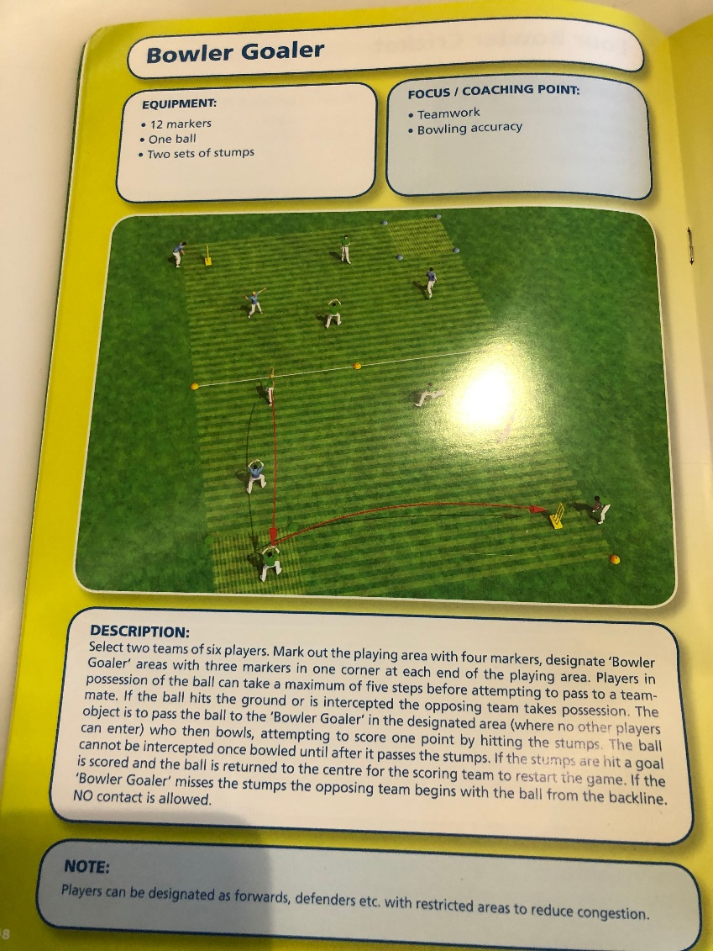
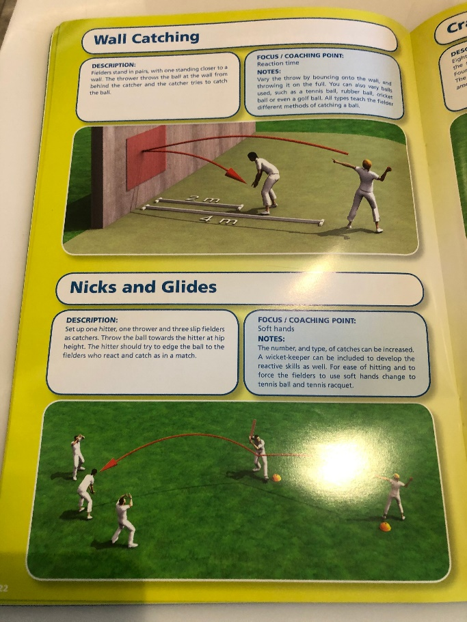
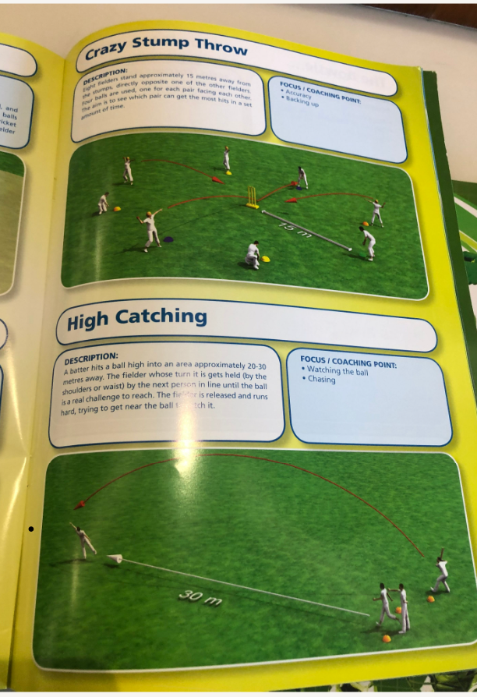
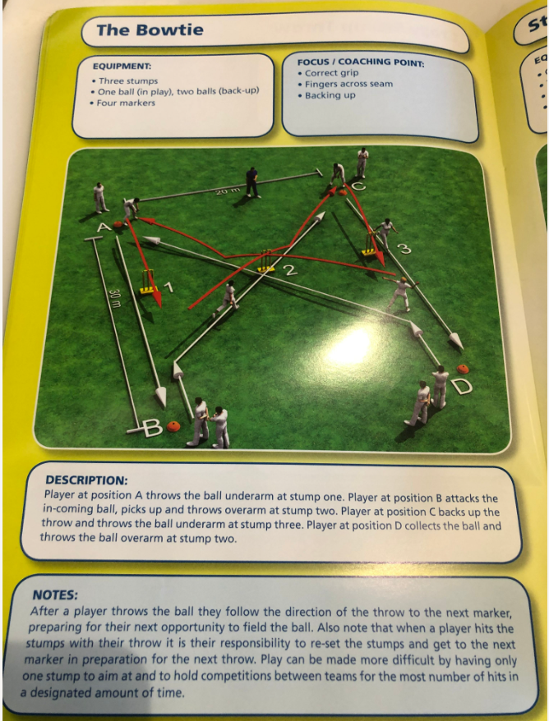
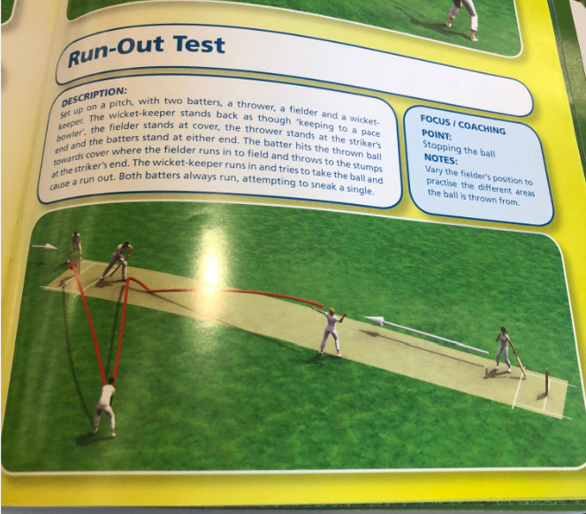

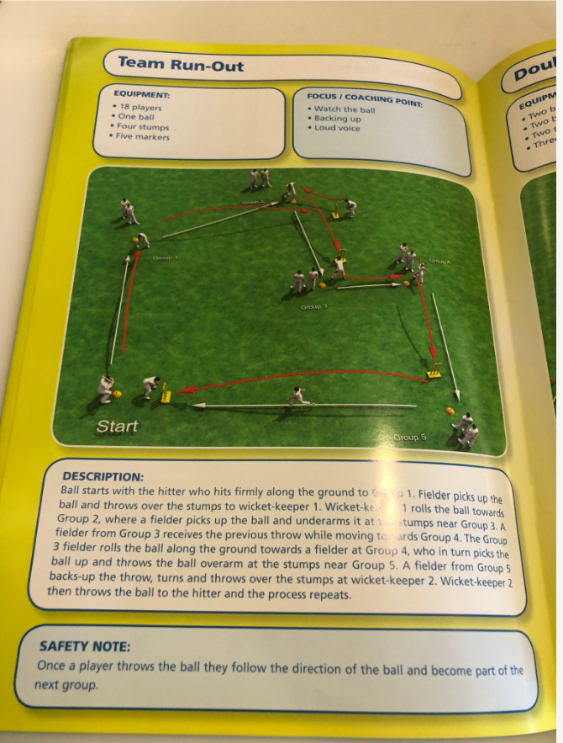
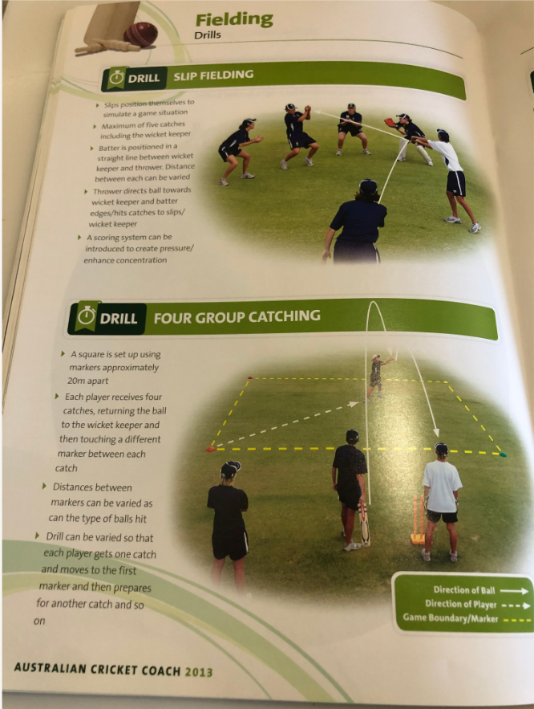

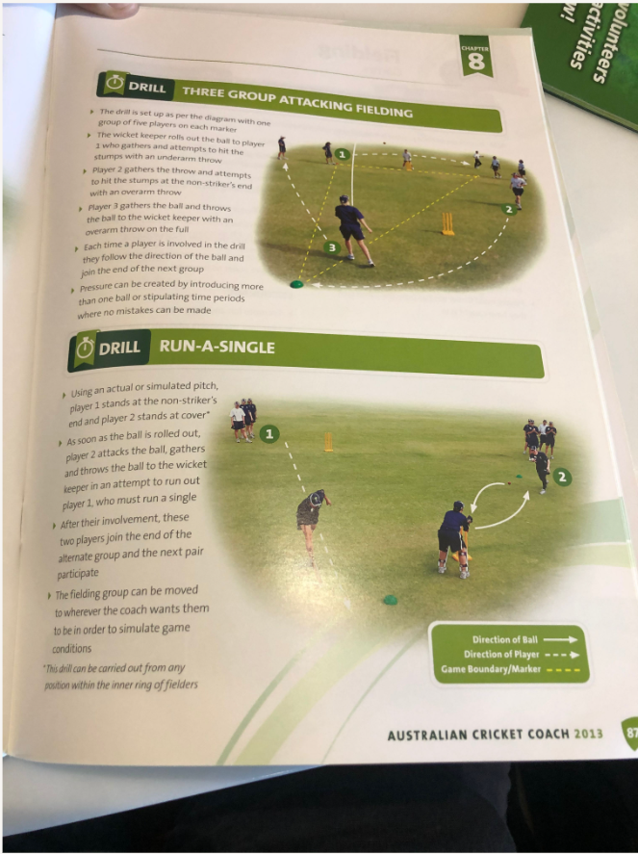
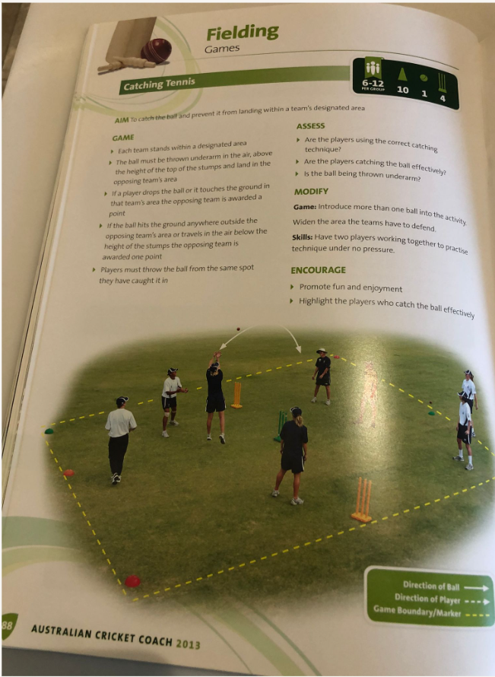

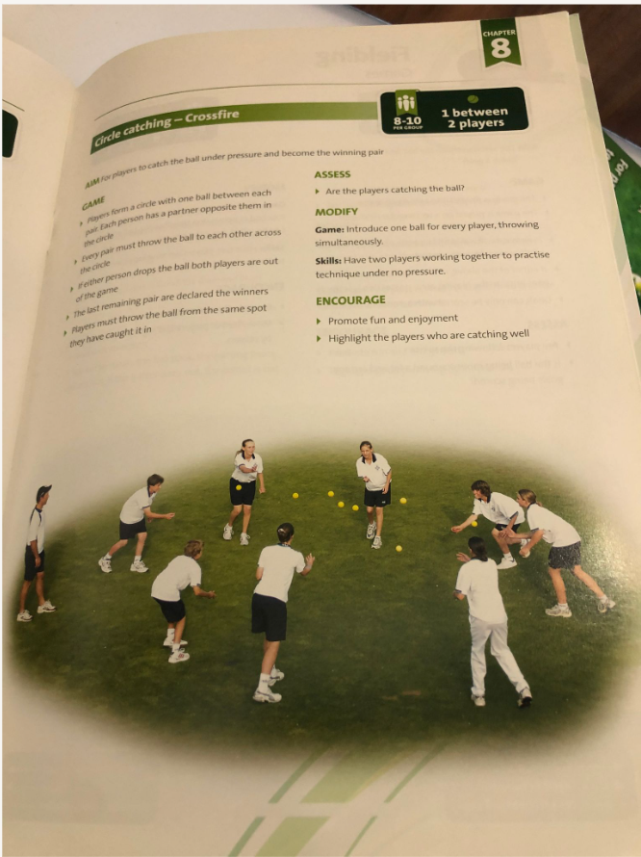

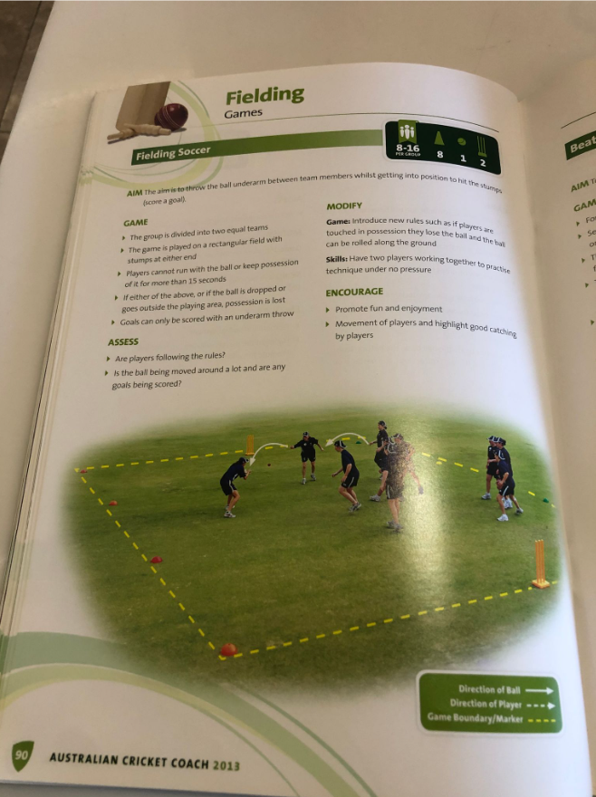

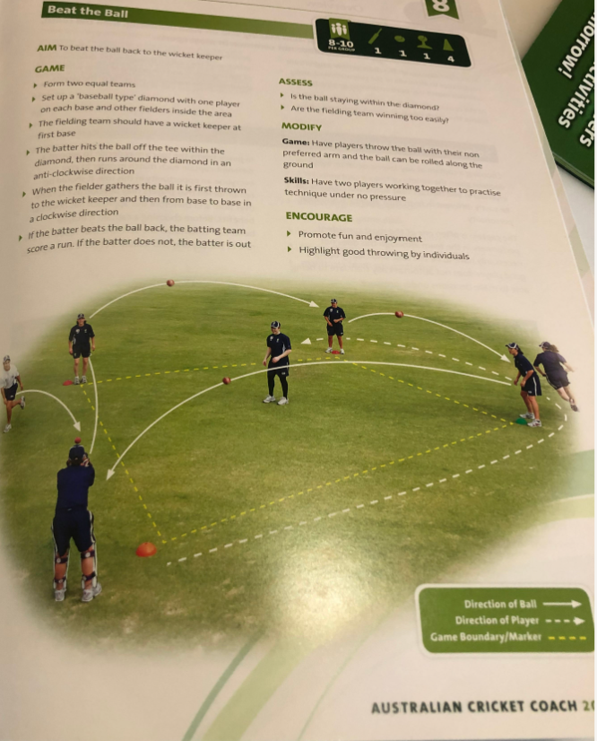

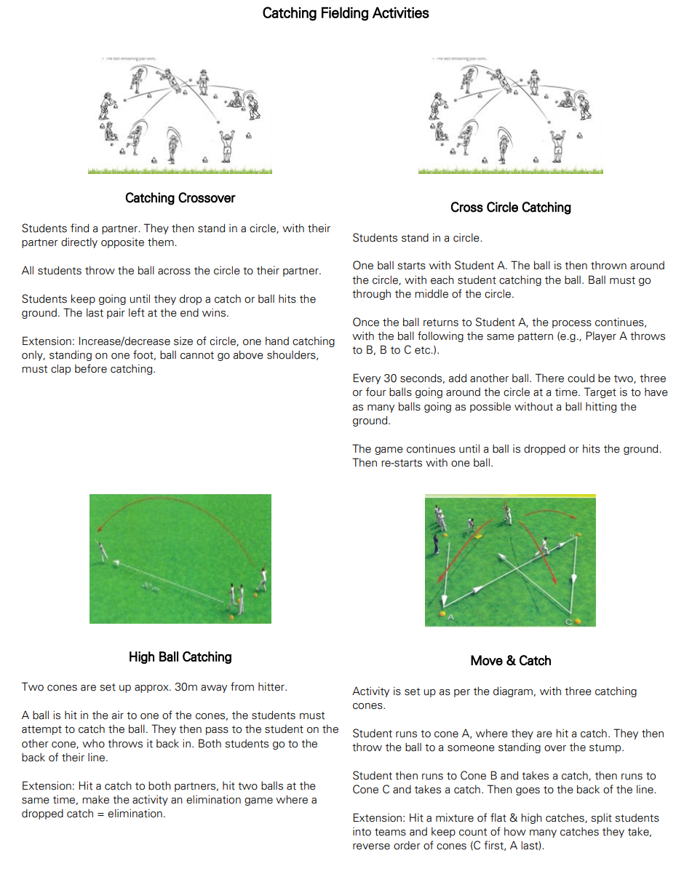
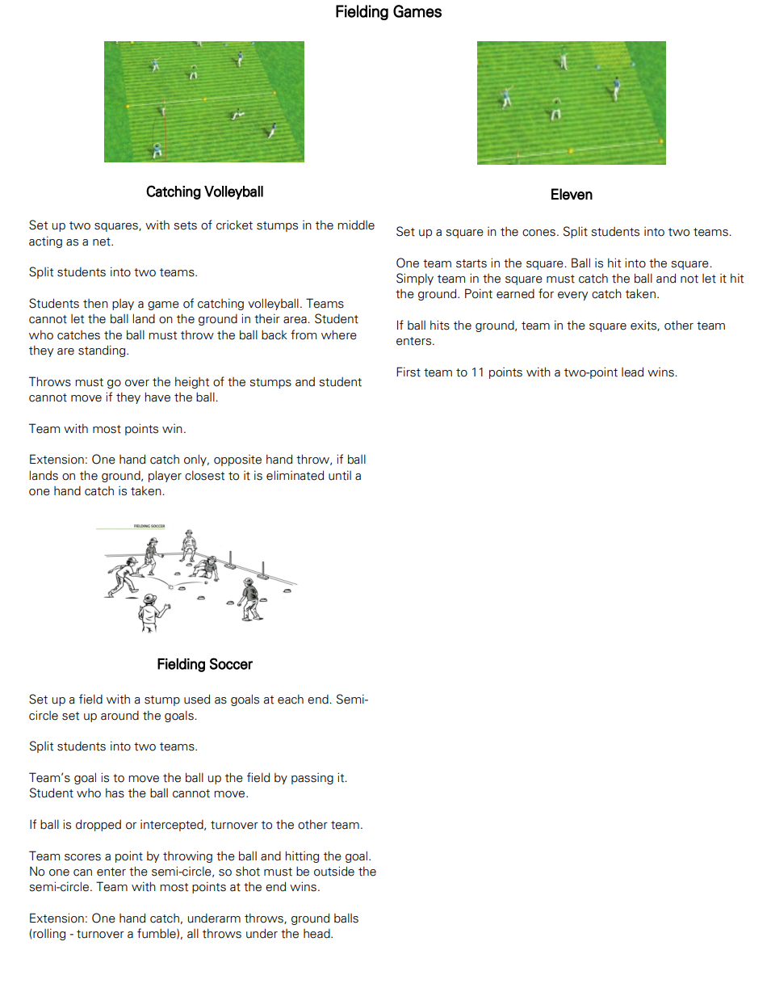

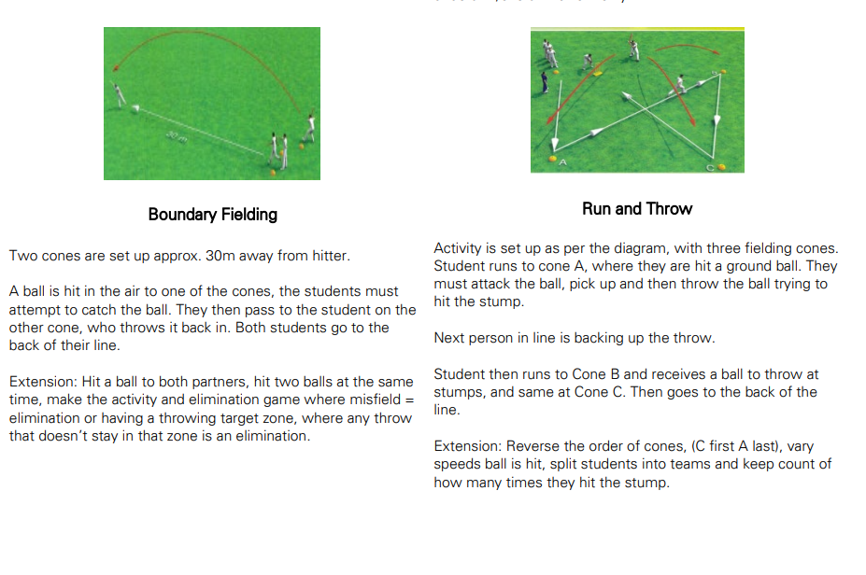
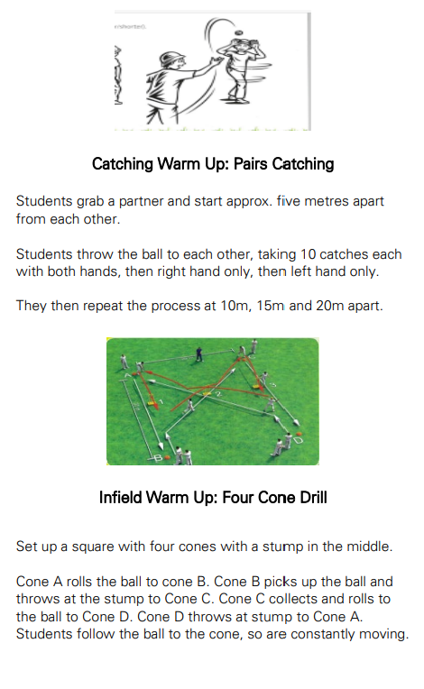

Running Between the Wickets

How to run:
Loud calls – yes, no or wait. No calls like ‘run,’ ‘no run’ or ‘yeah mate.’
Run hard.
When turning; look in the direction the ball is, get low and reach out to place your bat over the line.
When sliding your bat; reach out, used the edge of your bat to slide along the ground, don’t run too far past the stumps.
Golden rule – whenever we run, always be ready to run another as overthrows are very common in junior cricket and batters can take advantage of these mistakes from fielding teams, DO NOT run too far past the crease, as you may not be able to take advantage of an overthrow.
Note; if the ball hits the stumps when you are in and the ball ricochets away, you are ALLOWED to run, if fielder throws the ball and it hits the batter and ricochets away, you are NOT ALLOWED to run, it is against the spirit of the game, and at Carina we always want to uphold the spirit of the game.
When to run:
Batters need to judge whether they can make it to the other end, factoring in where the ball is, the quality of the fielder and the speed of the batters. Comes with practise.
When running an additional run, a good guide to use is whether the fielder has picked up the ball or not. Only a guide.

Running Between the Wickets Drills

Running practise – coach nominates how many and where the ball is hit, and the players have to run accordingly, making sure they follow all the key points.
Pairs cricket – players bat in pairs, and aim to score as many runs as possible (no boundaries), they lose points for getting out, not running properly, or making the wrong calls. Gain points for runs (can give bonus points if you want too).
Nets practise – coach sets up markers to represent the angle of fielders, batters make the appropriate call based on where they’ve hit and how hard, players then run with their partner batter, and ensure all the key points are followed. Can introduce a points system or suitable tasks (push ups) to help reinforce the basics. Another addition is to have three batters net and have a reserve batter, he/she would replace a batter who doesn’t run properly, and they become the reserve. By introducing an elimination, it further incentives the players to be accountable for their running.
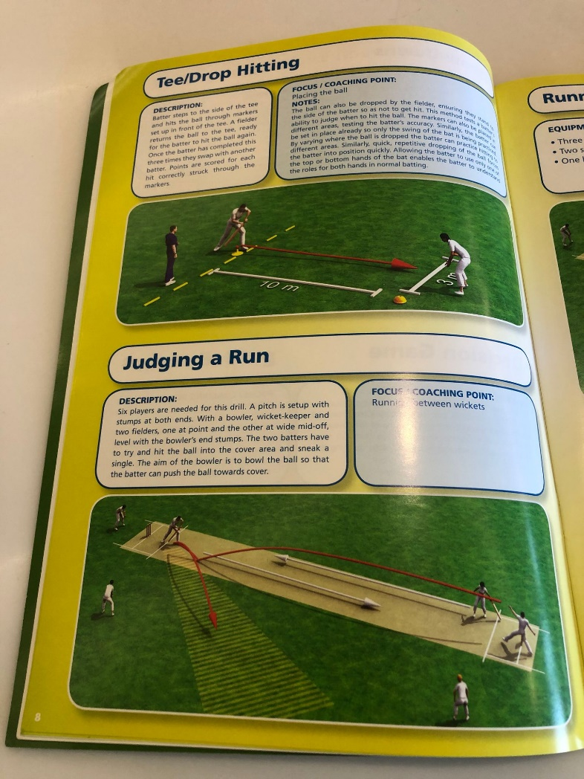
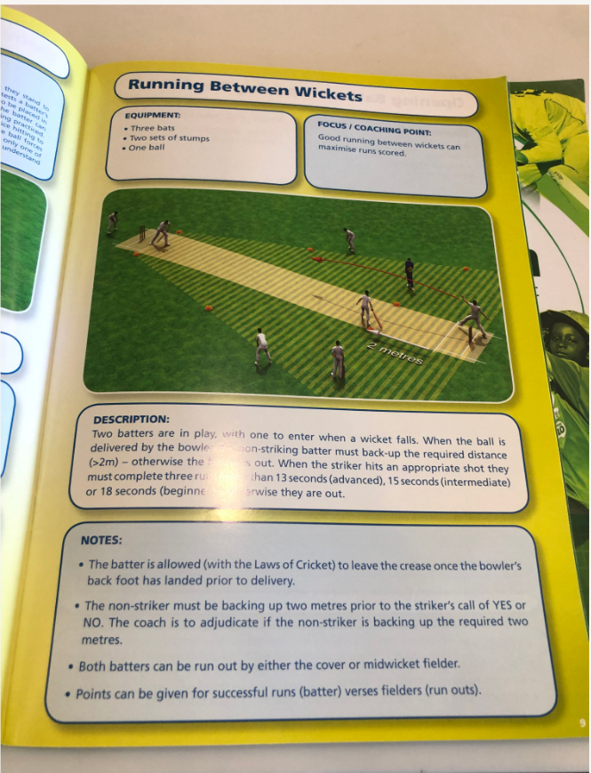
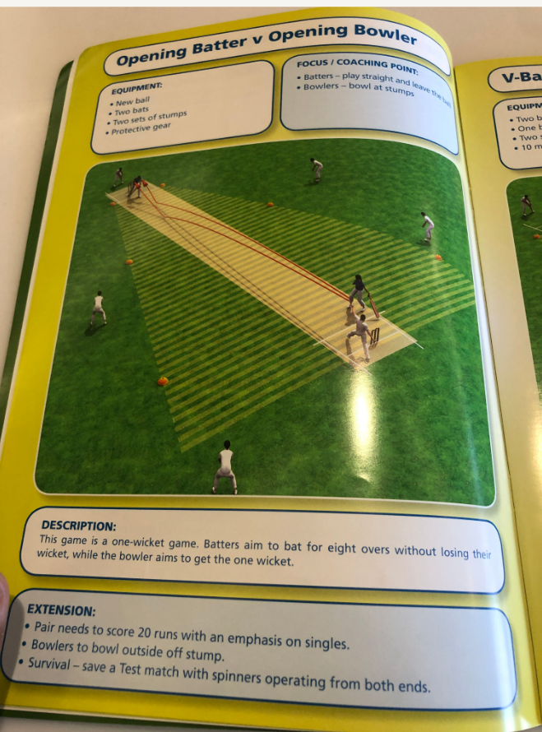
General Cricket Field Drills / Games

Pairs cricket – whichever team scores the most runs wins, can add targets on the field to promote hitting the ball in different areas.
Off side only – batters must score on the off side only to improve that area of their game (they lose runs if the play leg side), relies on bowler / thrower being accurate though.

